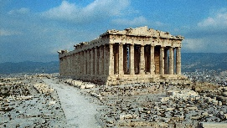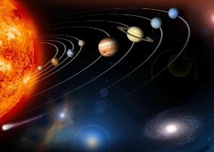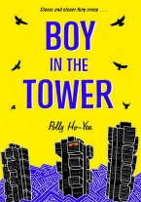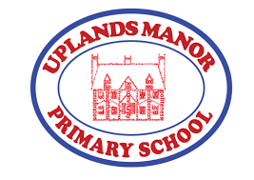

**English**

In Spring term, we will be focusing on two quality texts: The Boy in the Back of the Tower and Survivors. The first book is a story, providing great comparative opportunities. The second book is full of short, real accounts of people surviving various disasters. Children will be writing their own stories and also their own survival guide. They will be learning how to use relative clauses, parenthesis and commas for clarity.

**Music**

Digital music explanation using Garageband, Loops and Incredibox**.**

**Geography**

This term we will be covering volcanoes and earthquakes. They will look at how volcanoes are formed and how what causes earthquakes. They will learn how we measure earthquakes and where we would expect to find them.

**History**

This term, children will explore why Ancient Greece has had such a long and dramatic legacy as well as working as history detectives to piece together the fragments from the past. They will ask historical questions about Ancient Greeks and compare sources for historical enquires

**R.E.**

Children will focus on the Easter story and what Christians believe Jesus did to save them

**PSHE**

This term, we will cover our dreams and goals units. Please see our school website for more information.

**Spring Term Year 5**

**Talks/Workshops**

**Wonderdome work shop (Space)**

**P.E.**

They will learn to perform safe self-rescue in different water based situations. They will learn swim competently, confidently and proficiently over a distance of at least 25 metres using breast stroke, front crawl and back stroke.

**Design and Technology**

Complete 3D cad design using TinkerCad

**French**

Children will to talk about pets they do or do not have.

**Visits**

**Library visit**

**Swimming weekly**

**Computing**

Children will use espresso coding where they can fix bugs and develop their coding skills.

**Art**

Select and place textures to create a collagraph plate, applying an understanding of the material.

**Science**

Our unit this term is Earth and Space. The children will describe the movement of the Earth and other planets relative to the sun in the solar system. They will look at the movement of the moon relative to the Earth. Also, they will be able to describe the Sun, Earth and moon as approximately spherical bodies.

• Use the idea of the Earth’s rotation to explain day and night and the apparent movement of the sun across the sky.

**Maths**

This term, we will be continuing with multiplication and division, including multiplying 4-digit numbers by 2-digit numbers and applying this to problem solving. They will learn how to divide a four-digit number by a 1-digit number. We will be covering decimals, fractions and percentages. They will also look at fractions of amounts and multiplying fractions.

